Methods by Abdur Rafay

How to auto-delete a file.

(by just double clicking or set an expiry date for a file to be deleted)

***Method to delete file by just double clicking.***

1. Write code:

Open notepad and write the above code.

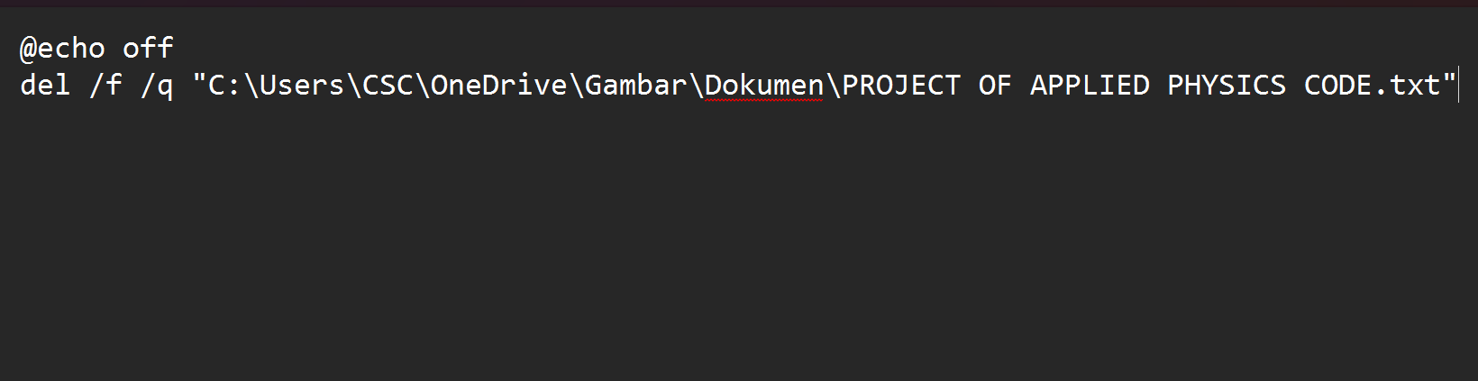

You need to copy your file path by press shift on keyboard and right clicking on your file then select

copy as path then you paste it just like above.

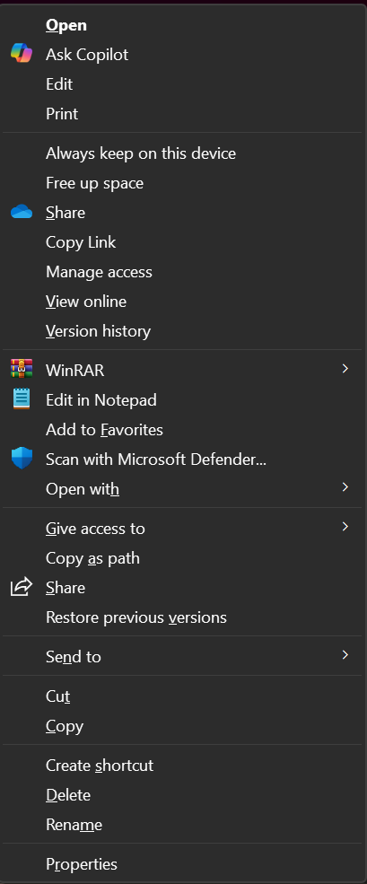

1. Save your file(this file helps you to delete the file you selected)

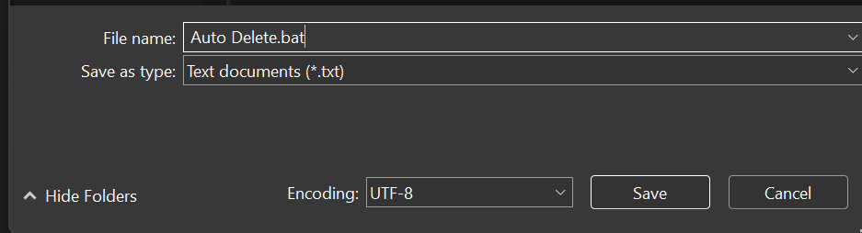

1. How it looks

It looks like this in desktop your (I said this because I saved this in it).



It looks like this on your PC screen.

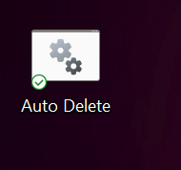

1. How it runs:

By double clicking on the file on your PC screen or desktop it runs and automatically deletes your file.

***Method to delete file by setting an expiry date for it.***

1. Open task scheduler



It is present in your windows you don’t need to install it whether you use any version of windows.

1. Click

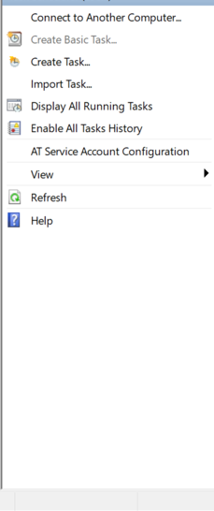

On left click on create basic task.

1. Add name

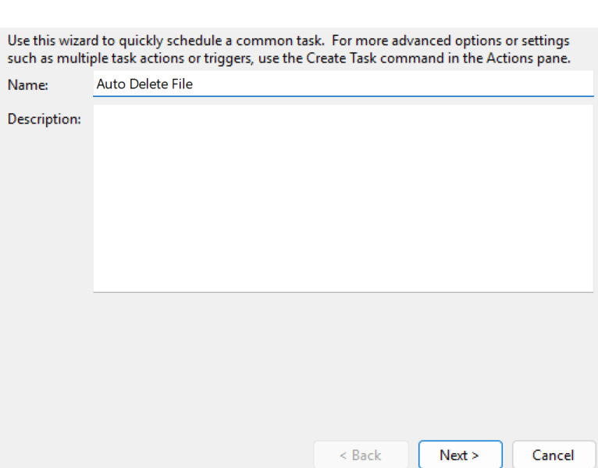

After add name of your choice click next

1. Set duration:

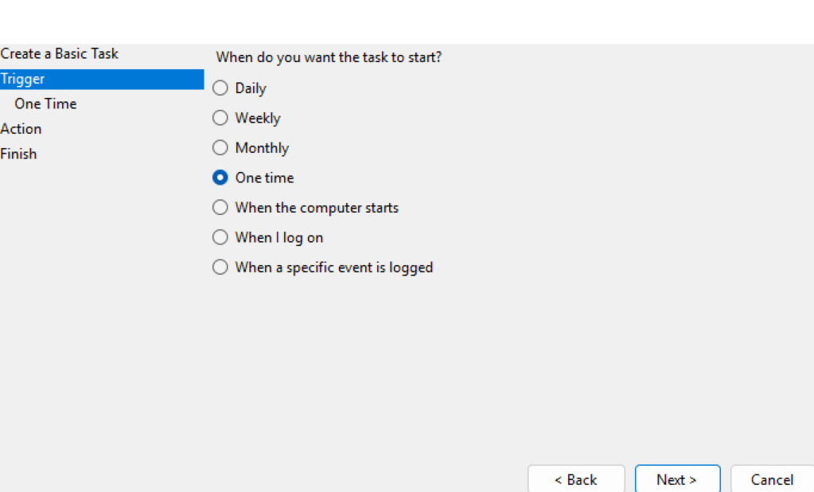

Select what you want depending on how much files

You want to delete.

1. Set time and date:

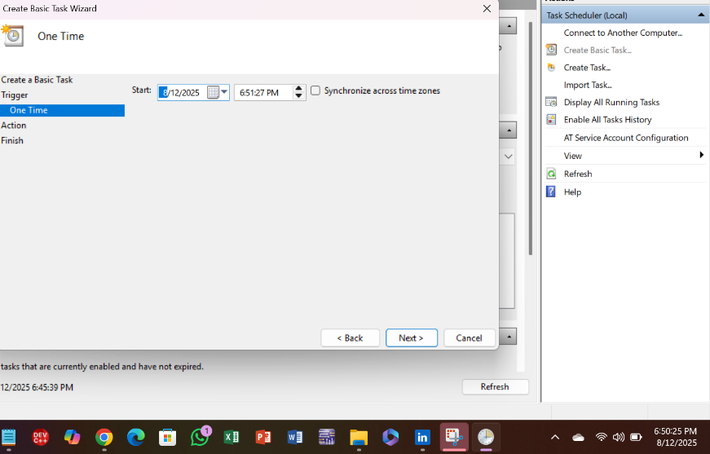

Set date and time of your choice.

1. Set program:

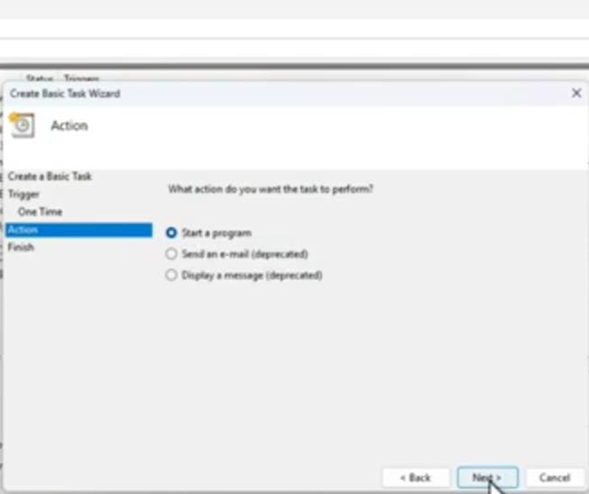

1. Browse the file you make to delete files.

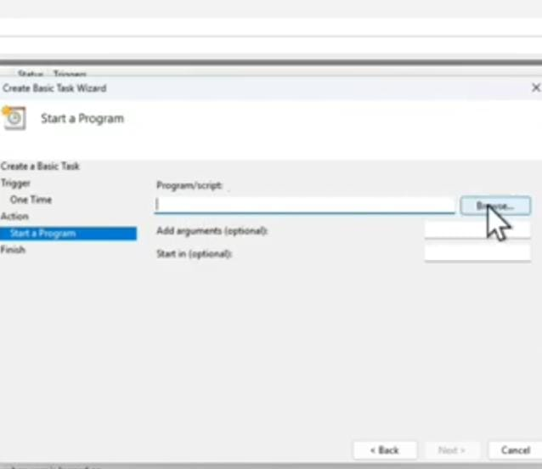

Click on your script(file you make).

1. Finish

After click on finish the function of deletion activates and it deletes files on the exact same time and date which you selected.

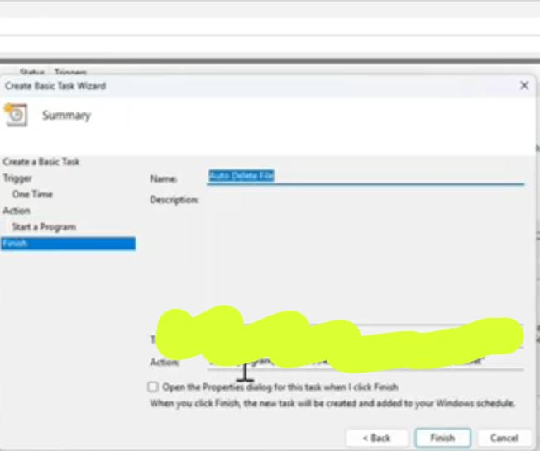

Thank you